Release document-Milestone 2
Document ID: ASP-DRSYS-RD-02
Author(s): Rajesh K
Table of Contents

1. Sections Delivered 2
2. Perforce Check-in 2
3. Execution Machine 3
Milestone1 Executable 3
Milestone2 Executable 4
4. Machine Settings 4
Execution machine 4
5. Cucumber execution Report 5
6. Jenkins Execution 5
7. User Defined Report 5
8. Deliverables Attached 5
9. Others 6
Test Case Exceptions 6
Milestone1 7
Milestone2 7

Sections Delivered
Milestone 2 contains deliverables related to AMC Stage 2 – Part 2 items which are mentioned in the Test Automation Plan.
The following sections constitute AMC Stage 2 – Part 2 section,
  - Generate Patient List
  - Patient Education
  - Preventive Care
  - Smoking Status
  - Incorporate Clinical Lab Results – Manual Part
  - Medication Reconciliation

“Incorporate Clinical Lab Results – manual Part” test cases were added to the milestone2 deliverable as the test cases for the sections “Imaging results”, “Patient Electronic Access”, “Provide Clinical Summary” were not provide as it was expected to have some design changes. These will now be delivered as part of Milestone3 [Changes in the deliver y date of Milestone3 will be communicated]

The “Automation Traceability document” includes the overall details of the deliverables.

Perforce Check-in
The scripts developed in Aspire are shared across to DRSYS using Perforce shared by DRSYS. The scripts of Milestone 2 are checked in under the location //SQA/eHR_SQA/eHR
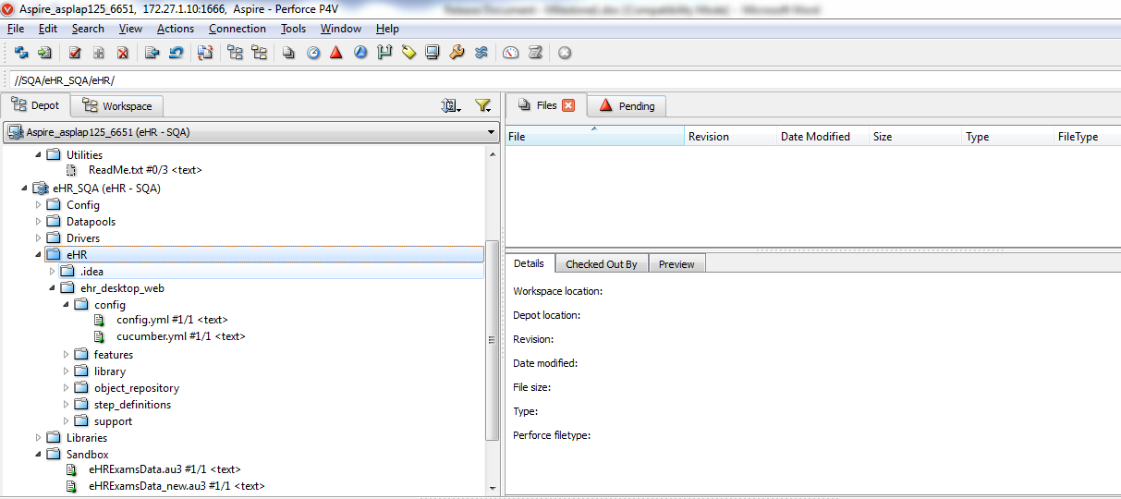

Execution Machine
As provided by DRSYS, the automation execution machine “172.27.101.114” will be used for testing the scripts by DRSYS QA. For now, the scripts are placed under the location “D:\Automation\eHR “.
The batch files are available in desktop under the folder “Automation Test Executables”.

Milestone1 Executable
Chrome_Issue_Fix.bat: Starts execution in Chrome browser for the issues reported by DRSYS QA [TC id – 676 and 678]
Internet_explorer.bat: Starts execution in IE browser for complete milestone1 deliverable.
Chrome.bat: Starts execution in Chrome browser for complete milestone1 deliverable.

Milestone2 Executable
Internet_explorer.bat: Starts execution in IE browser for complete milestone2 deliverable.
Chrome.bat: Starts execution in Chrome browser for complete milestone2 deliverable.
Machine Details:
Machine IP: 172.27.101.114
Machine Name: VM-eHR-Automation
IE version: 11.0.9600.16384
Chrome Version: 38.0.2125.104 m

Machine Settings

Execution machine
All the necessary environment settings are already set in the execution machine “172.27.101.114”. This includes setting up of Ruby, gem files needed [see section 5], browsers, IE Driver server and chrome driver server. Ruby Mine is also installed in this machine to help in the debug of failed scripts. The license for Ruby Mine is also added.

Application details:
- Ruby – 2.0.0
- IE Server Driver – v2.41.0.0(32- bit)
- Chrome Driver - v2.11.298604
- Ruby Mine – 6.0.3

Cucumber execution Report
The execution report consist of the following,
- HTML report : This is auto generated by Cucumber driver and has details of the complete execution
- Log Files : This can be used for report analysis purpose
- Screenshots: The screenshots for any failure is captured and the same is embedded to the HTML report. The file location of the screenshot is also mentioned in the log files generated.

Jenkins Execution
Jenkins is setup at DRSYS but execution using it has not been confirmed. After initial testing using Jenkins all the build jobs will be configured for automation execution.

User Defined Report
The User defined report will be generated under “custom_report” folder, it holds the HTML report files created based on cucumber generated report. Cucumber generated html report has all-in-one page report summary which is not convenient for analysis purpose. Hence, we have created a custom html report by splitting the cucumber-report into multiple html files. The consolidated execution summary will be in “report_home.html” file and will have the links to all other feature files holding grouped scenarios report data. This report includes all execution details along with the screenshot for failed cases.

Deliverables Attached
Following are the deliverables which are shared with this release,
- Scripts [shared through Perforce as mentioned in section 2]
- Verification Points document
- Automation Traceability document

Others

Test Case Exceptions
The following test cases will not be executed with IE 11 as the IE driver server has issues with opening the application in 2 different windows. But, this will execute with chrome browser.
QC Test ID | Section | Title
6243 | Patient Education | Patient Education Material for patients with office visits within reporting period
6244 | Patient Education | Patient Education Material for patients with no office visits within reporting period
6245 | Patient Education | Patient Education does not consider period.patients seen outside reporting
6246 | Patient Education | Patient Education does not consider patients with non face-to-face visits
6247 | Patient Education | Patient Education does not consider patients with inpatient exams
6248 | Patient Education | Patient Education does not consider patients with inactive exams
3398 | Med Reconciliation | Stage 2 Med Reconciliation does not take into account patients seen by EP outside reporting period.
5511 | Med Reconciliation | Stage 2 Med Reconciliation does not take into account non Face to Face patients.
5512 | Med Reconciliation | Stage 2 Med Reconciliation does not take into account Inpatients seen by EP during reporting period.
5513 | Med Reconciliation | Stage 2 Med Reconciliation does not take into account patients with inactive visit during RP
5514 | Med Reconciliation | Stage 2 Med Reconciliation with first time visit and reconciliation by adding medication.
5515 | Med Reconciliation | Stage 2 Med Reconciliation with first time visit and reconciliation clicking None Known.
5516 | Med Reconciliation | Stage 2 Med Reconciliation with not first time visit with EP and TOC.
6563 | Med Reconciliation | Stage 2 Medication Reconciliation delete scenario - 1
6565 | Med Reconciliation | Stage 2 Medication Reconciliation delete scenario - 3
6566 | Med Reconciliation | Stage 2 Medication Reconciliation delete scenarios - 4

Milestone1
- eRX mailbox should be up and running without any issue in 172.24.101.113
- The medication “Acyclovir (Buccal) 50 mg” should be changed to controlled substance. This is the medication which is used for testing test cases related to controlled substance[Test Case id : 5812]
- Screen Resolution should be minimum of 1280 x 1024

Milestone2
Following unique values should be available in DB for Lab Results execution,
SR. No | SNOMED_CODE | SNOMED_DESCRIPTION
1 | 419984006 | Inconclusive (qualifier value)
2 | 82334004 | Indeterminate (qualifier value)
3 | 42425007 | Equivocal (qualifier value)

